FANTASTIC VIETNAM DISCOVERY
Routing: Hanoi - Halong Bay - Da Nang - Hoi An – Ho Chi Minh City – Mekong Delta
Tour Style: Nature, Culture & Relaxation Tour
Tour Start: in Ha Noi / Tour End: in Ho Chi Minh City
Trip duration: 12 Days - 11 Nights

DAY 1: HANOI – ARRIVAL
DAY 2: HANOI – FULL DAY CITY WALKING AND STREET FOOD TOUR (B/L)
DAY 3: HANOI – FULL DAY TRIP TO HOA LU – TAM COC – MUA CAVE GROUP TOUR (B/L)
DAY 4: HANOI – TUAN CHAU MARINA - HALONG BAY (SIC TOUR) (B/L/D)
Overnight on cruise.
DAY 5: HALONG BAY – private car to NOI BAI AIRPORT – FLIGHT TO DANANG – ONWARD TO HOI AN (B/BR)
DAY 6: HOI AN – HALF DAY WALKING TOUR (B)
Optional Tour: Half day My Son Sanctuary Tour (L)
DAY 7: LEARNING FARMING, FISHING AND COOKING CLASS IN TRA QUE VILLAGE (B/L)
DAY 8: HOI AN – FREE AT YOUR OWN LEISURE (B)
Optional Tour: Full day Bana Hills & Golden Bridge Tour (L)
DAY 9: HOI AN – DANANG AIRPORT – FLIGHT TO HO CHI MINH CITY (B)
DAY 10: HO CHI MINH CITY – FULL DAY CITY TOUR & CU CHI TUNNELS (B/L)
DAY 11: HO CHI MINH – FULL DAY EXPLORE MEKONG DELTA AREA (B/L)
DAY 12: HO CHI MINH – DEPARTURE (B)

Details itinerary:
DAY 1: HANOI – ARRIVAL
Upon arrival at Noi Bai International Airport, meet your local guide and transfer to your hotel for check-in. Take some time to rest and recover from your flight.
Depending on your arrival time, you may take a short walk around the Old Quarter or enjoy a cup of Vietnamese coffee by Hoan Kiem Lake, watching local life unfold.
Overnight in Hanoi.
DAY 2: HANOI – FULL DAY CITY WALKING AND STREET FOOD TOUR (B/L)
After breakfast, begin your walking city tour to discover the historical and cultural heart of Hanoi. Start with the Ho Chi Minh Mausoleum Complex, where you’ll learn about Vietnam’s most respected leader, then visit the One Pillar Pagoda, a symbol of purity and resilience. Continue to the Temple of Literature, Vietnam’s first university, rich in Confucian heritage.
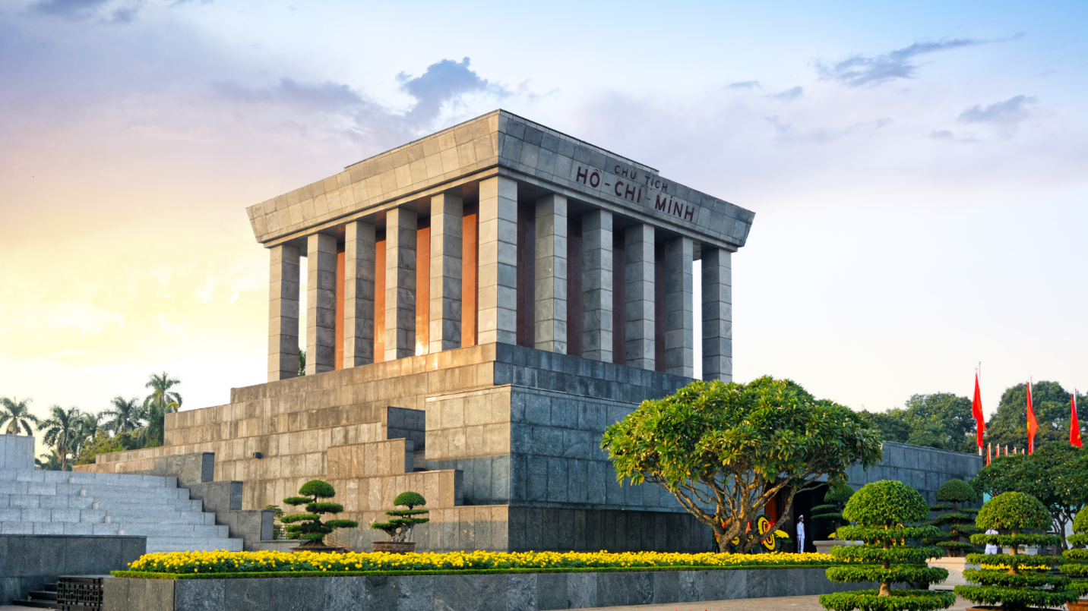
Enjoy lunch at a local restaurant before exploring the charming Old Quarter in the afternoon. Wander through narrow alleys bustling with shops, street vendors, and colonial architecture. Taste Hanoi’s signature dishes such as Bún Chả, Bánh Cuốn, and Chè, while your guide shares stories of the city’s rich culinary traditions.
End your day at the famous Train Street, where you can sip strong Vietnamese coffee as trains pass through the narrow lanes — a truly unique Hanoi experience.
Overnight in Hanoi.
DAY 3: HANOI – FULL DAY TRIP TO HOA LU – TAM COC – MUA CAVE GROUP TOUR (B/L)
After breakfast, depart from Hanoi on a scenic drive through lush countryside toward Ninh Binh Province, known as the “Halong Bay on land.”
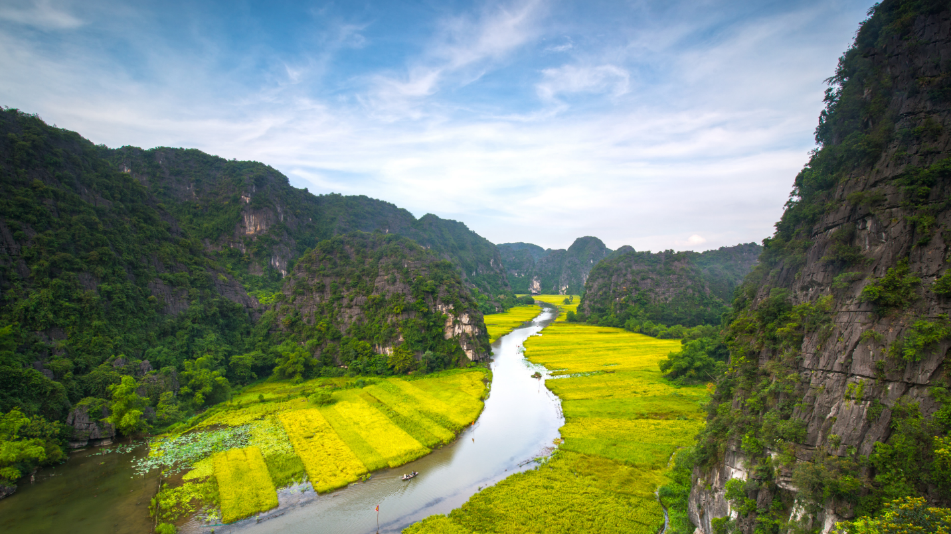
Your first stop is Hoa Lu Ancient Capital, where you’ll visit the historic temples of King Dinh and King Le and learn about Vietnam’s early dynastic history. Continue to Tam Coc, where you’ll board a traditional sampan boat, gliding along calm rivers surrounded by limestone cliffs and green rice fields — a serene and picturesque experience.
Enjoy lunch at a local restaurant featuring regional specialties.
In the afternoon, visit Mua Cave, where a short climb rewards you with breathtaking panoramic views of Tam Coc valley and the Ngo Dong River below — one of the most iconic vistas in Vietnam.
Return to Hanoi in the late afternoon.
Overnight in Hanoi.

DAY 4: HANOI – TUAN CHAU MARINA - HALONG BAY (SIC TOUR) (B/L/D)
08:30 After breakfast, the shuttle bus will pick up at your hotel in Hanoi Old Quarter. Enjoy the landscape of the Red River Delta on the way to Ha Long Bay.
11:30 Arrive at Tuan Chau Marina, get checked in at the waiting lounge.
12:00 Embark on cruises, enjoy the welcome drinks while being given a short briefing. Check in to your room and get ready for a tasty lunch.
12:30 Enjoy Vietnamese and international lunch and the picturesque scenery of the bay, pass by the most beautiful areas: Incense Burner, Dog Stone Islet, Fighting Cock Islet, Three Coconuts Island.
15:00 Continue to explore Halong Bay by visiting Luon Cave. This is also an ideal place for kayaking, get up and close to the timeless beauty of Ha Long Bay.
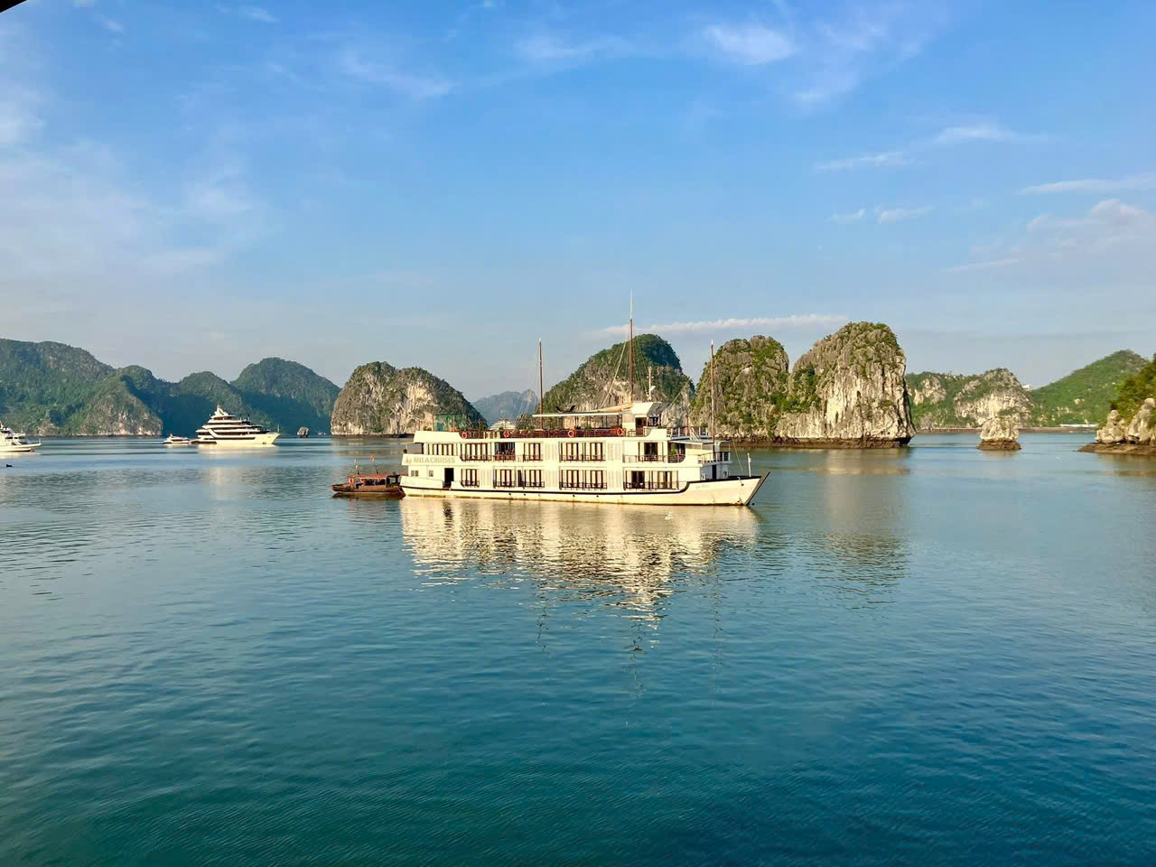
16:30 Visit Titov Island - a small limestone island with one of the best sandy beaches in Ha Long Bay. You can immerse yourself in emerald water and hike to the top for stunning panoramic views of the bay.
17:30 Back to the boat and take part in a cooking demonstration on our sundeck, enjoy the bar’s Happy Hour (buy 01 get 01) program and watch the magnificent sunset over the bay.
(Option: Massage service available. Please book with Cruise Manager directly)
19:00 Deluxe dinner is served. Enjoy our traditional and fusion dishes prepared by our talented chefs.
21:00 After dinner it’s your time to enjoy at our bar and spa, fish squid or watch a movie in cabin, play cards, chess or relax on the sundeck.
Overnight in a quite Halong Bay Area.

DAY 5: HALONG BAY – private car to NOI BAI AIRPORT – FLIGHT TO DANANG – ONWARD TO HOI AN (B/BR)
06:15 Seeing the bay in the morning is a wonderful experience, awaken all your senses with a Tai Chi session on the sundeck while gathering vitamin sea to refresh yourself before enjoying breakfast.
07:00 Coffee, tea and pastries for breakfast are served in the restaurant.
07:30 Visit Sung Sot Cave - a magnificent and largest limestone cave as its original name: Grotte des Surprising. The beautiful stalactites and stalagmites formed over millions of years are the reward after the steep climb on Bo Hon Island.
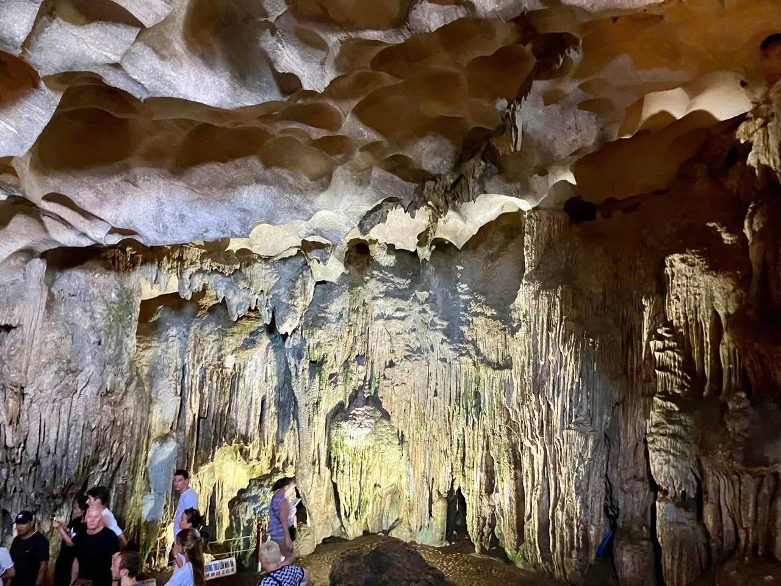
(*) Note: Proper shoes are highly recommended when it’s wet.
09:30 Back to the cruise ship. Check out and settle your bill at the reception.
10:00 Have brunch while cruising back. Relax on the sundeck or in the restaurant.
11:30 Disembark at Tuan Chau Marina. You will be met by our private driver. Then be transferred directly to Noi Bai International airport to depart to Da Nang on:
DOMESTIC FLIGHT
Upon arrival at Da Nang Airport, you will be met by our driver. We will then transfer to your hotel in Hoi An for relaxing or wandering around on your own.
Overnight in Hoi An.
DAY 6: HOI AN – HALF DAY WALKING TOUR (B)
After breakfast, enjoy a half-day walking tour of Hoi An Ancient Town, a UNESCO World Heritage site known for its timeless beauty and cultural charm. Stroll through lantern-lined streets, visit the Japanese Covered Bridge, Tan Ky Old House, and Hoi An Market, where colorful stalls showcase local handicrafts and spices.
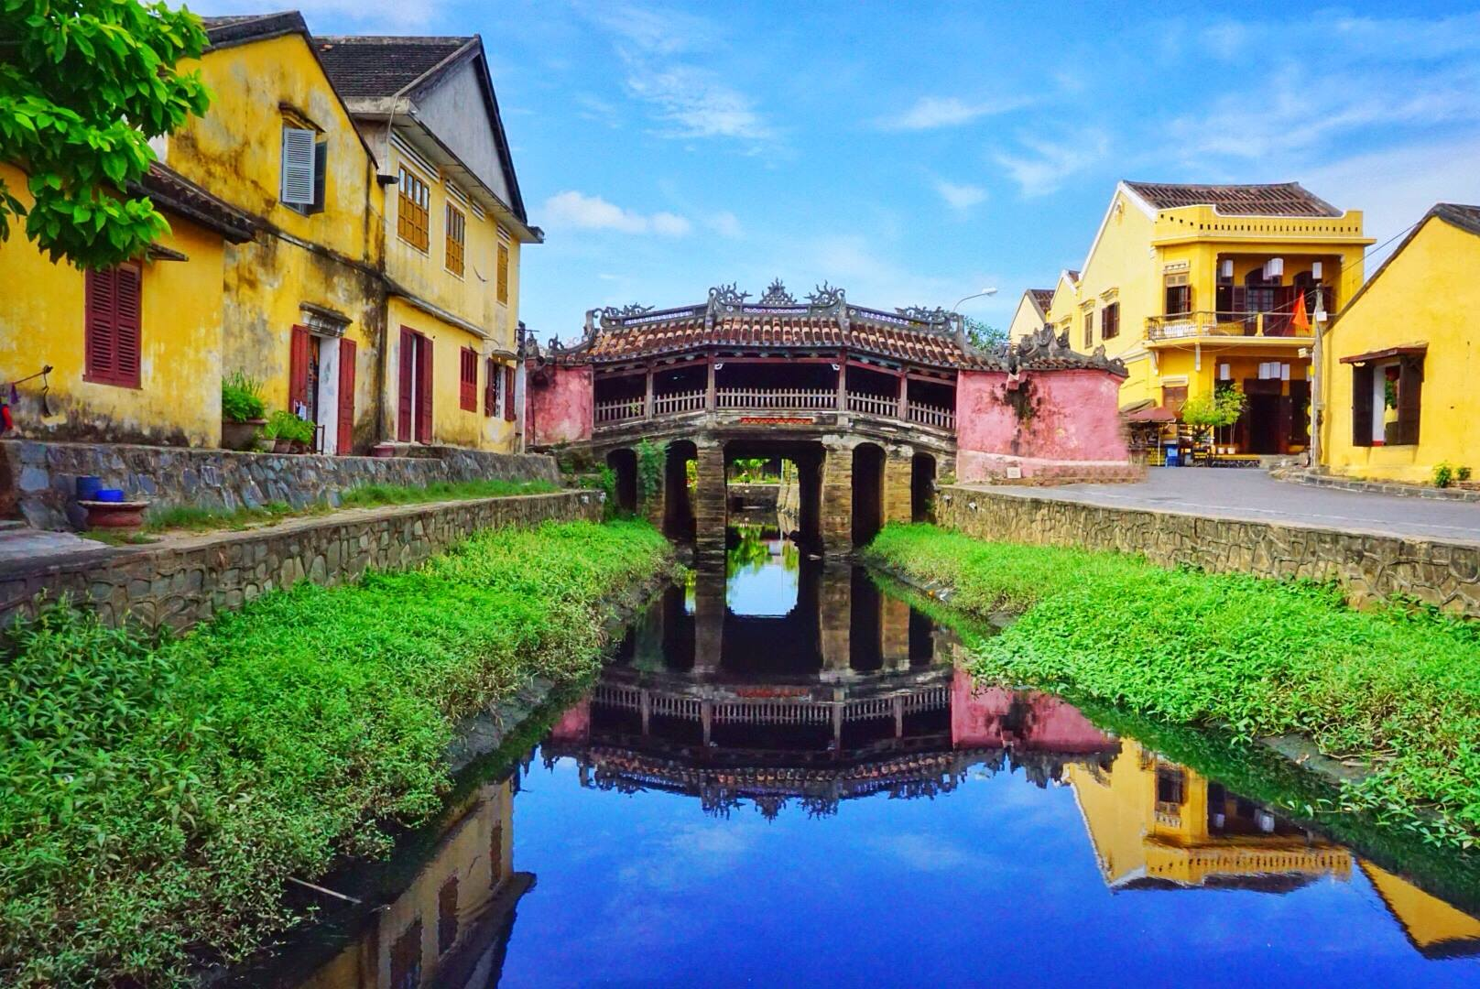
The afternoon is free at your leisure — perfect for relaxing by the riverside, visiting a local tailor, or exploring Hoi An’s cafés and art galleries.
Optional Tour: Half day My Son Sanctuary Tour (L)
AM: At 7:30 – 8:00 am, our guide will pick you up at your hotel in the center of Hoi An town and transfer you to My Son Holy Land, the ruins of the Cham people and an imperial city during the Cham dynasty. Here, you will have the opportunity to explore and learn about the techniques used by the ancient Cham people in making red bricks to build towers—a secret that remains largely unknown. You can view a large complex of religious relics comprising more than 65 architectural works, which will fascinate those interested in architectural art. In 1999, UNESCO designated the Cham architecture in My Son as a World Cultural Heritage Site. Additionally, you will have the chance to enjoy traditional music performed by Cham girls in their colorful uniforms.
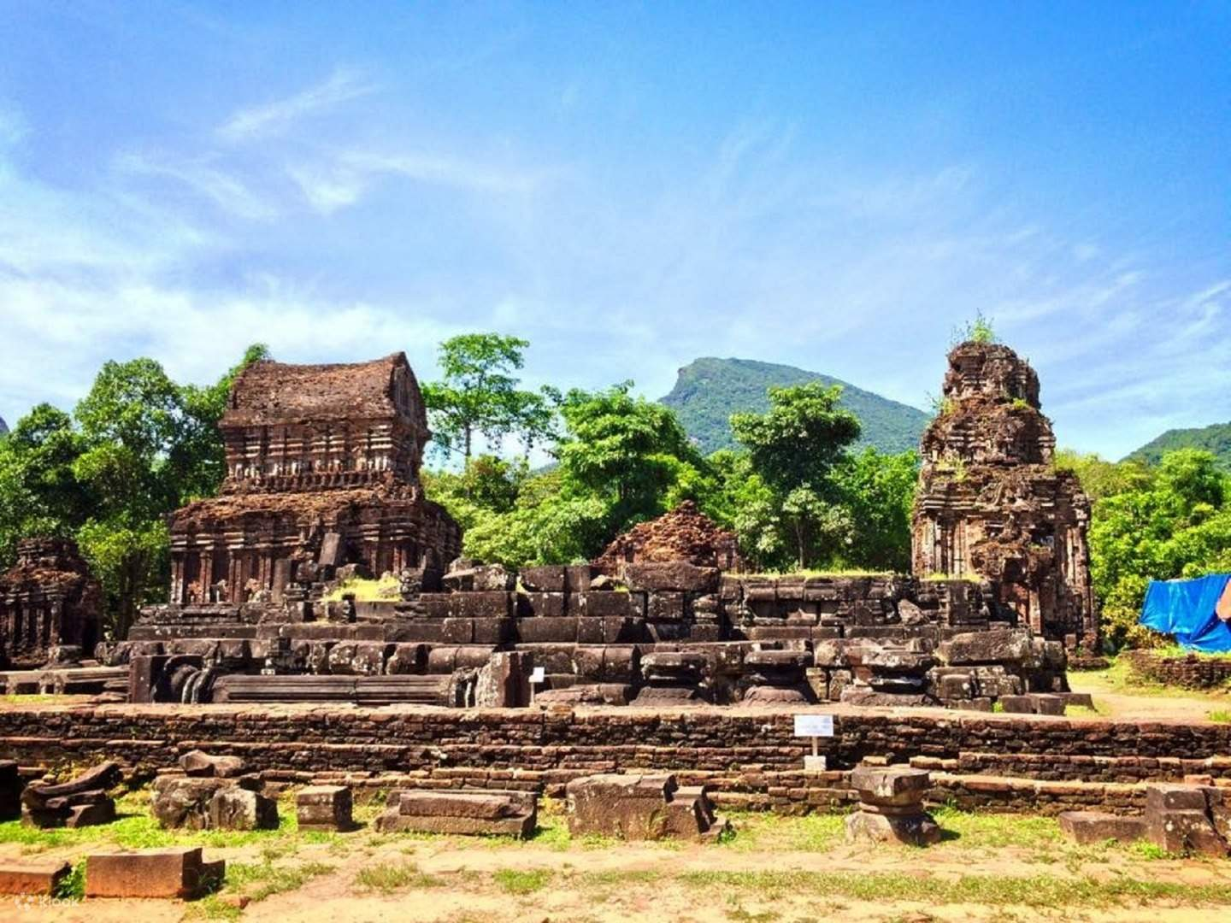
Following your visit, you will be transferred to the boat pier for a boat trip along the Thu Bon River back to Hoi An Ancient Town. You will return to your hotel on your own, and the tour will end.
Overnight in Hoi An.
DAY 7: LEARNING FARMING, FISHING AND COOKING CLASS IN TRA QUE VILLAGE (B/L)
AM: Early this morning, our guide will welcome you at your hotel in Hoi An and transfer you to visit the Green Bay Mau Water Coconut Forest. Here, you will have the chance to row a basket boat, enjoy the tranquil atmosphere, explore the revolutionary base of Hoi An from the Vietnam War, and learn how to use fishing tools to catch field crabs. Next, you will cycle through the beautiful countryside to Tra Que Vegetable Village, 3 km from Hoi An Ancient Town. Upon arrival, you will be welcomed with friendly smiles and a special drink: "E" water or local tea. You will dress in farming clothes and take a short walk around the garden where local farmers use traditional methods without electrical machines. Under the guidance of a local, you will learn how to prepare and make the land, fertilize it with green manure before growing vegetables, and water the newly planted vegetables. Afterward, you will return to the house to relax by soaking your feet in Vietnamese herbs, a refreshing way to unwind after working on the farm. Then, you will join a cooking class with the family, where you will learn how to prepare Hoi An's special foods and enjoy lunch with them.
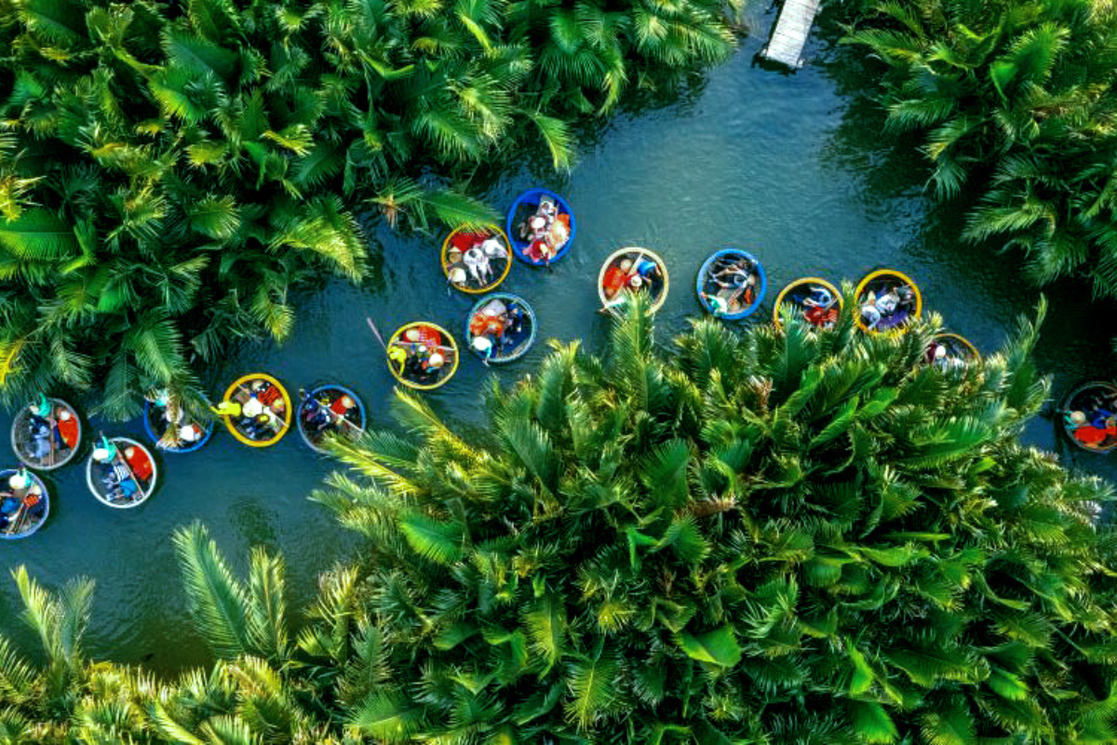
PM: After lunch, you will be transferred to Thanh Ha Ceramic Village to see how local people create pottery. You will have the opportunity to make a piece of pottery under the guidance of the workshop owner and receive a clay whistle called “To He” as a gift before leaving. From there, you will embark on a boat trip to Cam Nam Fishing Village to gain more fishing experience under the instruction of local people. You will practice catching fish and using fishing nets. Finally, you will be transferred back to your hotel in Hoi An, where the tour will end.
Overnight in Hoi An.
DAY 8: HOI AN – FREE AT YOUR OWN LEISURE (B)
Enjoy breakfast at your hotel and spend the day at leisure to relax or explore at your own pace. You may stroll through Hoi An’s charming streets, shop for souvenirs, unwind at a riverside café, or enjoy the beach nearby.
Optional Tour: Full day Bana Hills & Golden Bridge Tour (L)
AM: At 8:00, our guide and driver will pick you up at your hotel in Hoi An or Da Nang and transfer you to discover Ba Na Hills, located 25 km southwest of Da Nang City. To reach the summit, you will take a cable car from the base and enjoy spectacular views of the forest. Upon arrival, you will have the opportunity to sightsee and take photos at the world-famous Golden Bridge with its iconic Giant Hand. Continue to the flower garden Le Jardin D’amour, which features many kinds of beautiful flowers, and visit the Debay Wine Cellar, which houses a variety of wines. Take another cable car ride to reach the Old French Villas at an elevation of 1,138 meters to experience the architecture. Enjoy lunch at a restaurant.
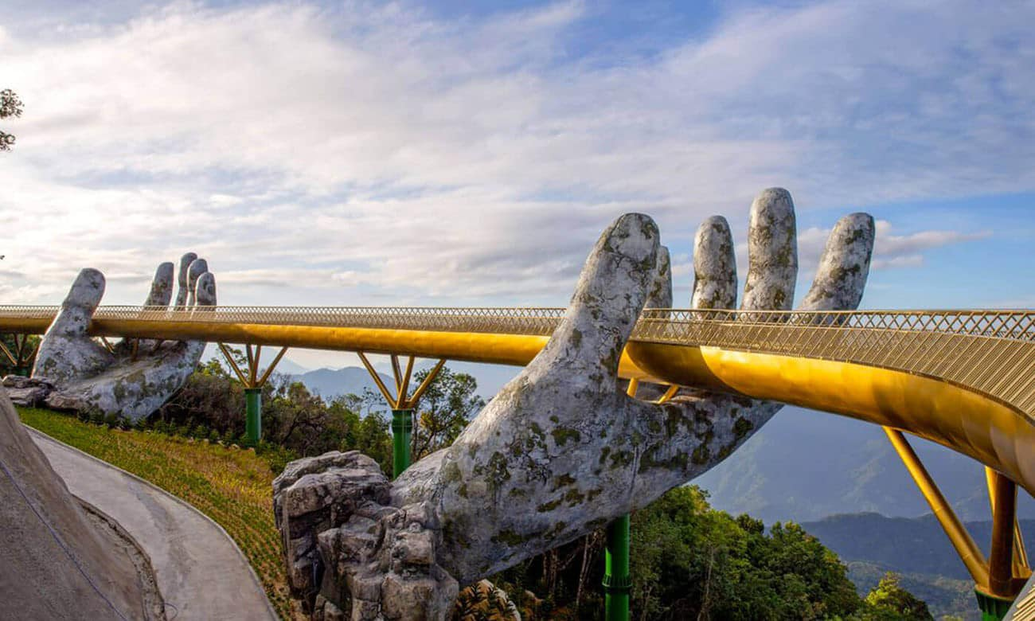
PM: After lunch, you will have more time to explore and play games at the Fantasy Theme Amusement Park (most games and the 4D movie are included in your tour package, but some games with rewards will require an additional fee). Following your visit, you will take the cable car back to the base. Our guide and driver will transfer you back to your hotel. The tour will end upon your return.
Overnight in Hoi An.
DAY 9: HOI AN – DANANG AIRPORT – FLIGHT TO HO CHI MINH CITY (B)
After breakfast, enjoy some free time to relax or take a final stroll around the charming streets of Hoi An. At the appointed time, transfer to Danang International Airport for your flight to Ho Chi Minh City.
DOMESTIC FLIGHT
Upon arrival, meet your local guide and transfer to your hotel for check-in and relaxation. The rest of the day is free at your leisure to explore the city’s vibrant atmosphere.
Overnight in Ho Chi Minh City.
DAY 10: HO CHI MINH CITY – FULL DAY CITY TOUR & CU CHI TUNNELS (B/L)
Today we spend a half day exploring the captivating Ho Chi Minh City. The most places of interest are located near the town center. We pass by the now-demolished wartime American Embassy on our way to the Reunification Palace. This famous edifice was a former residence of the President of Southern Vietnam until end of April 1975. Close to the palace are some striking French colonial structures including the Notre Dame Cathedral and the Old Sai Gon Post Office. We follow these with a visit to the Jade Emperor Pagoda and the War Remnant Museum with a wealth of images from the notorious conflicts. The sightseeing ends up with a walk around the retail Ben Thanh Market where anything and everything is for sale!
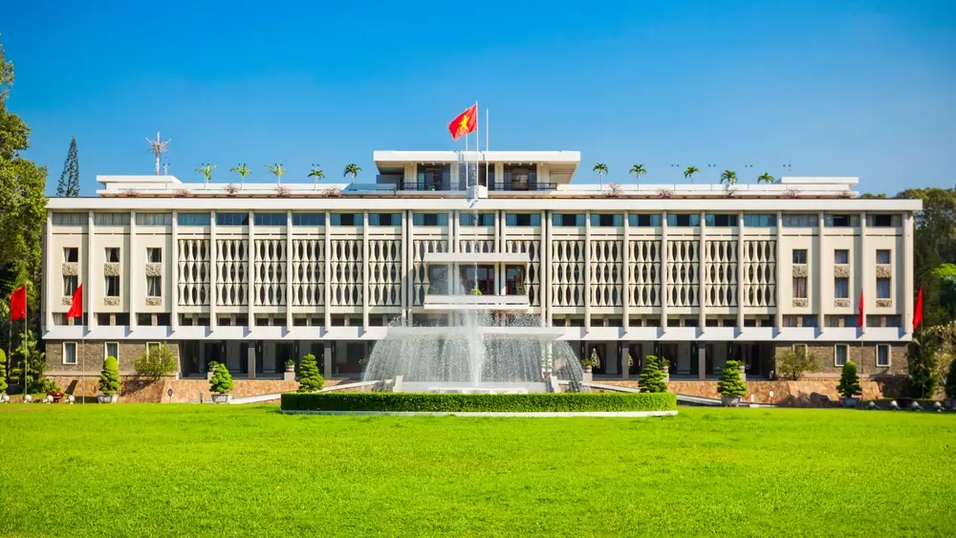
Have a lunch at a local restaurant.
After lunch and short break, we start to transfer about 30km north-west of Ho Chi Minh City to Cu Chi town. Cu Chi tunnels were used as the base from which the Vietnamese mounted their operations of the Tet Offensive in 1968. The incredible underground network in Cu Chi stretched over 200 kilometres and became legendary during the American war. The extensive tunnels have been specially constructed with living areas, weapon factories, filed hospitals, command centres, plus accommodation. Today we have an excursion to Cu Chi Tunnels to visit an exposition hall and a widened section of the tunnels to get a feel of the underground life. There are also possibilities to fire off rounds from an AK47 or MK16 at the nearby rifle range. Return to Ho Chi Minh City.
Overnight in Ho Chi Minh city.
DAY 11: HO CHI MINH – FULL DAY EXPLORE MEKONG DELTA AREA (B/L)
After breakfast, depart from Ho Chi Minh City for a scenic drive to the Mekong Delta, Vietnam’s fertile “rice bowl.” Arrive in My Tho, where you’ll board a boat for a leisurely cruise along the Mekong River, passing stilt houses and lush fruit plantations.
Stop at local islands to visit a coconut candy workshop and honey farm, where you can taste tropical fruits and enjoy traditional folk music performed by villagers. Continue with a rowboat ride through small canals shaded by water coconut trees, experiencing the peaceful rhythm of local life.
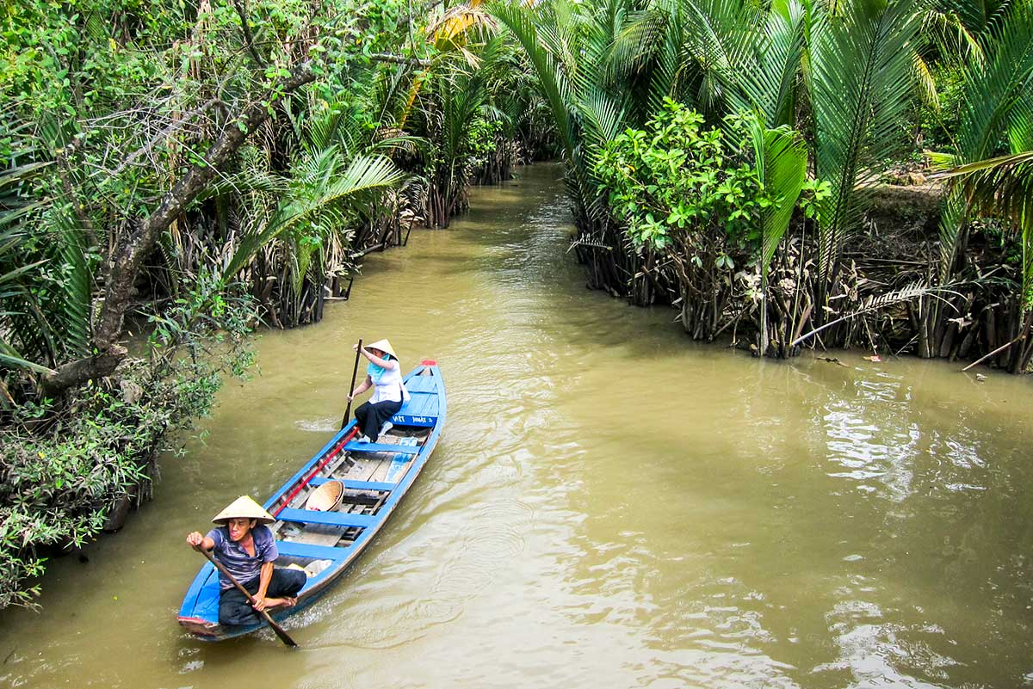
Enjoy lunch at a local restaurant with Mekong specialties before returning to the pier. Drive back to Ho Chi Minh City in the late afternoon.
Overnight in Ho Chi Minh City.
DAY 12: HO CHI MINH – DEPARTURE (B)
After breakfast, enjoy some free time to relax or explore the city at your own pace until your driver transfers you to Tan Son Nhat International Airport for your departure flight.
End of services!!

INCLUSIVE OF ABOVE PROGRAM:
- Accommodation in twin/double room with daily breakfast (check-in and check-out around noontime).
- 2Days/1Night cruise on board a cruise in Halong Bay (double/twin cabin on shared boat)
- 1-way shared luxury shuttle bus from Hanoi to Halong Bay; 1-way private car from Halong Bay - Noi Bai
- Services of a driver and air-conditioned vehicle during all tours and transfers.
- Experienced English-speaking guide during day tour.
- Entrance fees for all visits as mentioned in the itinerary.
- Meals (B/L/D) (Breakfast/Lunch/Dinner) as indicated in the program.
- 01 bottles of mineral water per person per day on days of sightseeing.
- Government’ tax

EXCLUSIVE OF ABOVE PROGRAM:
- Early check-in or late check-out.
- International & Domestic flight tickets (quoted separately)
- Meals (other than mentioned in the program)
- Additional transfer required due to any emergency situation.
- Visa - as per country requirements.
- Offering tips and expressing gratitude for guides and drivers is recommended at a rate of 5 USD /client /day for guides and 2 USD per client /day for drivers. Feel free to adjust the amount based on your satisfaction with their services.
- Travel insurance (we highly recommend that you purchase adequate insurance).
- Optional excursions and activities.

